**VARIOUS TASKS ON PARTITION OF MEMORY**

* **Extend root partition of the ec2 instance from 8 to 16**
* **Create new partition and add it to ec2 instance of 4GB**
* **Create 2Gb swap memory and attach to fstab entry as well**

**PLAN OF ACTION**

**Task 1.**

- First select the running instance and the volume attached to it and extend it to 16 GB

- Run growpart command on 1st partition of /dev/sda disk (we have used 1 as partition number because our root partition is 1st on the disk).

sudo growpart /dev/xvda 1

* growpart command will rewrite the partition table so that the partition takes all the space.

-df -h #print the name of your boot partition

-lsblk #show info on all your block devices

* Now run xfs_growfs command to extend the root filesystem,

-sudo xfs_growfs /dev/xvda1

**Task 2.**

- Navigate to the AWS management console and

- Create a new volume of 4GB and attach it to an existing running instance

**Task 3.**

– To follow the mentioned link and type in commands in the ec2 instance machine

**OUTPUT**

Task – 1 : Extended root partition to 16GB

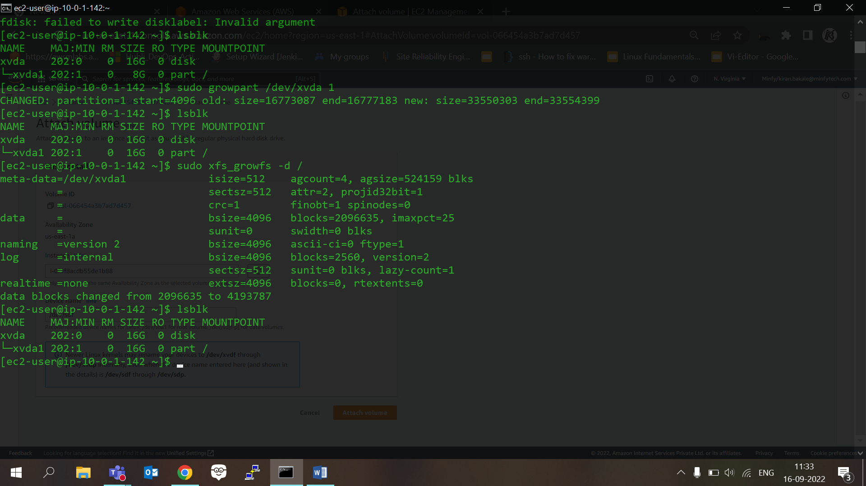

Task 2 – Added 4GB volume

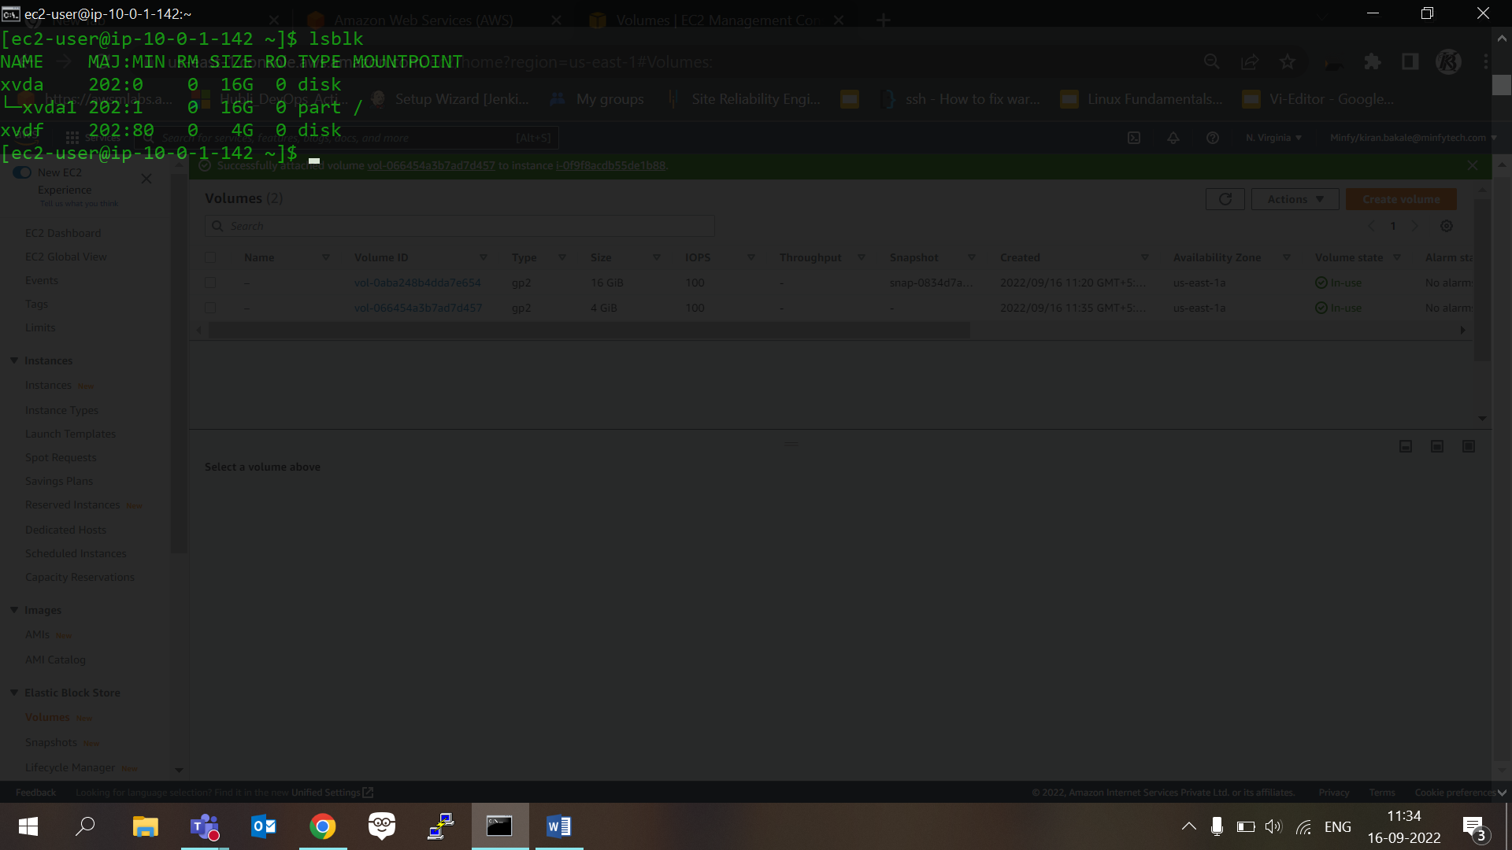

Task 3 -

Swap memory created

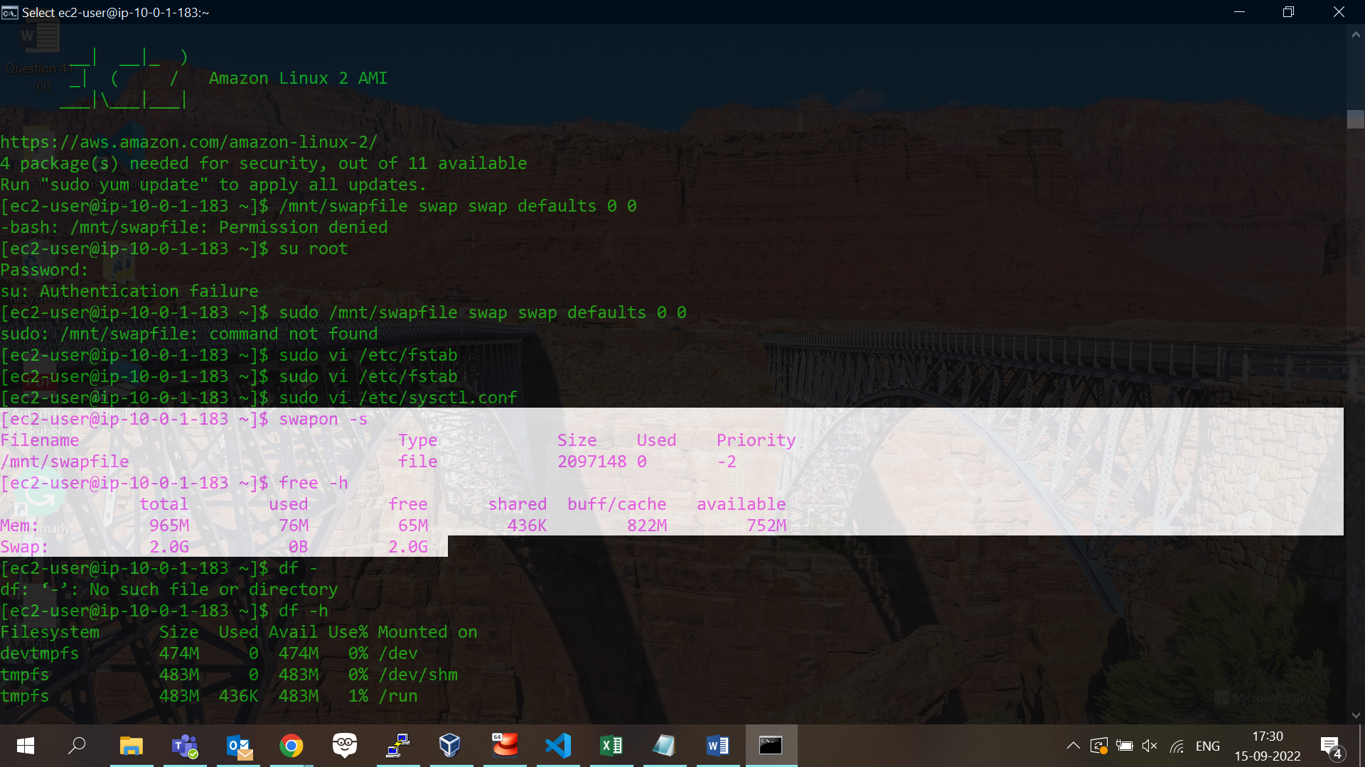

FStab entry

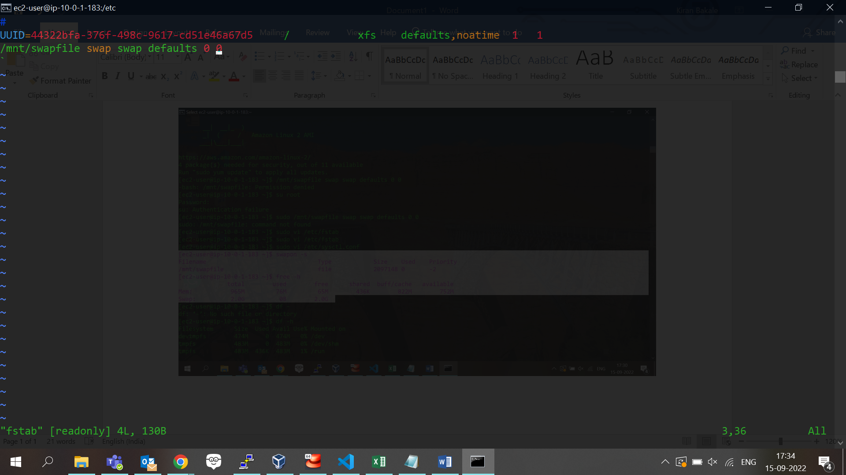

References

<https://www.tecmint.com/create-a-linux-swap-file/>

<https://www.youtube.com/watch?v=SwsdqGEh2t8>

<https://blog.ruanbekker.com/blog/2018/03/28/expanding-the-size-of-your-ebs-volume-on-aws-ec2-for-linux/>

<https://stackoverflow.com/questions/26770655/ec2-storage-attached-at-sda-is-dev-xvde1-cannot-resize>